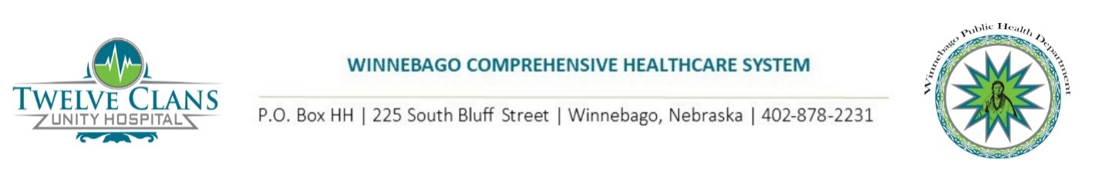Emilee Longuski

Communications Manager

Emilee.Longuski@WinnebagoTribe.com

Phone: 615-486-1767 *FOR IMMEDIATE RELEASE*

**WINNEBAGO REPORTS FIRST KNOWN CASE OF COVID-19**

WINNEBAGO, NE – Winnebago Comprehensive Healthcare System, which is comprised of the Winnebago Public Health Department and Twelve Clans Unity Hospital, has confirmed the first case of 2019 novel coronavirus disease (COVID-2019) in the local area of Winnebago. Testing was conducted with a sample taken at the individual’s home by the Winnebago Public Health Department’s Public Health Nursing Department and shipped via carrier to a certified laboratory to confirm diagnosis. This individual is in good condition and remains isolated at home to prevent spread of infection to others. To protect the patient’s privacy, no other details will be released at this time.

The individual who tested positive is suspected to have been a community-spread case. The Winnebago Public Health Department is actively investigating when the individual’s symptoms began and is reaching out to any potential contacts of the individual.

“The Winnebago Public Health Department and Twelve Clans Unity Hospital are working in cooperation to take all the appropriate steps to identify potential exposures, ensure necessary isolation precautions are taken, and provide testing to individuals when warranted. We continue to urge community members to stay home as much as possible and to practice social distancing if you must go out for essential supplies,” said Danelle Smith, Winnebago Comprehensive Healthcare System CEO.

COVID-19 is a respiratory illness with no known cure or vaccine. Community members experiencing shortness of breath, sore throat, runny nose, and cough are urged to call the COVID-19 Hotline at (402) 922-1508. Per Center for Disease Control and Prevention (CDC) guidelines, it is recommended that individuals stay home except to get necessary medical care. Individuals with underlying conditions, such as diabetes or those with compromised immune systems, are the most high-risk for contracting the virus.

Prevention measures include washing your hands often with soap and water for at least twenty seconds each time and routinely cleaning frequently touches surfaces. Other recommendations include social distancing and remaining at least 6 feet away from each other with groups of no more than 10 people.

Winnebago Comprehensive Healthcare System has been taking many important steps to further protect the health and safety of the community. These steps, among others, have included implementing a no visitor policy within the hospital, increasing the frequency of cleaning facilities, making certain services available remotely, implementing a drive-thru pharmacy, and placing staff on telework status when possible.

*Winnebago Comprehensive Healthcare System is operated by the Winnebago Tribe of Nebraska and consists of two divisions. Twelve Clans Unity Hospital is a 13-bed state-of-the-art healthcare facility that serves an estimated 10,000 Native Americans who live on the Winnebago Reservation and in the surrounding region. Health care services provided by the hospital include an ambulatory care clinic, inpatient care, express care clinic, pharmacy, radiology, emergency care, medical laboratory, physical therapy, social services, and more. The Winnebago Public Health Department strives to create and maintain a healthy community by providing a wide range of total health and wellness programs. These programs include physical, mental, safety, and social services that benefit the Winnebago community.*

###